Nicholas Lichtsinn

Lab 8

6/2/2021

Part 1 - Introducing Functions, Views, and Stored Procedures

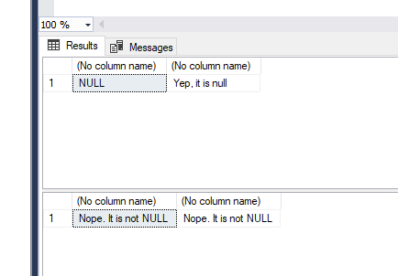

2. Lines 49-53 are selecting the top 10 User ID’s with the most VidCasts in descending order. The code knows that the vc_User record with userID=20 has 22 records because in the function we created we said to count the number of Vidcasts for the given userID.
3. Lines 75 & 76 are calling the function vc_TagIDLookup that we just created, calling the tag ID that corresponds with the tag text that we input. Line 76 pulls NULL because there is not a TagID that corresponds with the tagtext ‘Tunes’.
4. In lines 94-104 we are creating a stored procedure to update a user’s email address where we have to input the username of the email we want to update so that we are not updating everything.
5. The UserLoginTimeStamp value will be different depending on when you call the AddUserLogin function. We could just run a SELECT statement with SELECT dbo.vc_AddUserLogin and then specify the username and location.

Part 2 - Putting It All Together

vc_UserIDLookup

1. vc_TagVidCastCount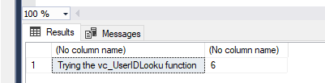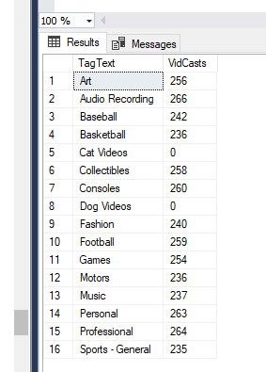
2. vc_VidCastDuration

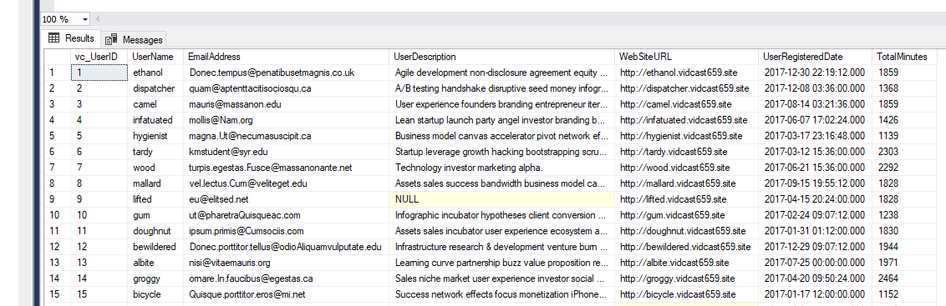

1. vc_TagReport

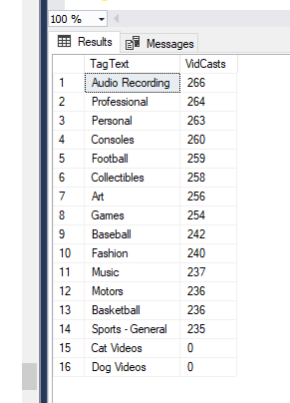

1. vc_MostProlificUsers

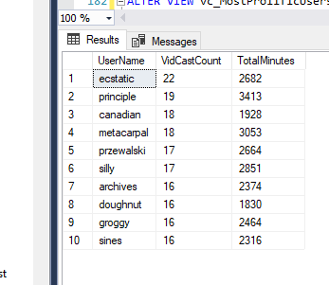

1. vc_AddTag

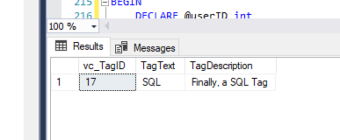

1. vc_FinishVidCast

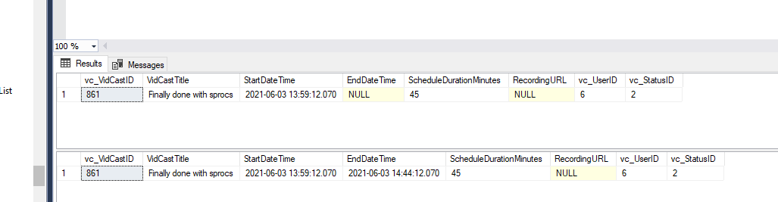

SQL CODE:

-- Declare a variable (we’ll talk about variables in a minute)

declare @isThisNull varchar(30) -- Starts out as NULL

SELECT @isThisNull, ISNULL(@isThisNull, 'Yep, it is null') -- See?

-- Set the variable to something other than NULL

SET @isThisNull = 'Nope. It is not NULL'

SELECT @isThisNull, ISNULL(@isThisNull, 'Yep, it is null') -- How about now?

GO

CREATE FUNCTION dbo.AddTwoInts(@firstNumber int, @secondNumber int)

RETURNS int AS

BEGIN

--First, declare the variable to temporariily hold the result

DECLARE @returnValue int -- the data type matches the "RETURNS" clause

-- Do whatever needs to be done to set that variable to the

-- correct value

SET @returnValue = @firstNumber + @secondNumber

-- Return the value to the calling statement

RETURN @returnValue

END

GO

SELECT dbo.AddTwoInts(5, 10)

GO

CREATE FUNCTION dbo.vc_VidCastCount (@userID int)

RETURNS int AS

BEGIN

DECLARE @returnValue int

SELECT @returnValue = COUNT(vc_UserID) FROM vc_VidCast

WHERE vc_VidCast.vc_UserID = @UserID

RETURN @returnValue

END

GO

SELECT TOP 10

*

, dbo.vc_VidCastCount(vc_UserID) as VidCastCount

FROM vc_User

ORDER BY VidCastCount DESC

GO

CREATE FUNCTION dbo.vc_TagIDLookup(@tagText varchar(20))

RETURNS int AS

BEGIN

DECLARE @returnValue int

SELECT @returnValue = vc_TagID FROM vc_Tag

WHERE TagText = @tagText

RETURN @returnValue

END

GO

SELECT dbo.vc_TagIDLookup('Music')

SELECT dbo.vc_TagIDLookup('Tunes')

GO

CREATE VIEW vc_MostProlificUsers AS

SELECT TOP 10

*

, dbo.vc_VidCastCount(vc_UserID) as VidCastCount

FROM vc_User

ORDER BY VidCastCount DESC

GO

SELECT * FROM vc_MostProlificUsers

GO

CREATE PROCEDURE vc_ChangeUserEmail(@userName varchar(20), @newEmail varchar(50))

AS

BEGIN

UPDATE vc_User SET EmailAddress = @newEmail

WHERE Username = @userName

END

GO

EXEC vc_ChangeUserEmail 'tardy', 'kmstudent@syr.edu'

SELECT * FROM vc_User WHERE UserName = 'tardy'

INSERT INTO vc_Tag (TagText) VALUES ('Cat Videos')

SELECT * FROM vc_Tag WHERE vc_TagID = @@IDENTITY

INSERT INTO vc_Tag (TagText) VALUES ('Dog Videos')

SELECT * FROM vc_Tag WHERE vc_TagID = SCOPE_IDENTITY()

GO

CREATE PROCEDURE vc_AddUserLogin(@userNAme varchar(20), @loginFrom varchar(50))

AS

BEGIN

DECLARE @userID int

SELECT @userID = vc_UserID FROM vc_User

WHERE UserName = @userName

INSERT INTO vc_UserLogin (vc_UserID, LoginLocation)

VALUES (@userID, @loginFrom)

RETURN SCOPE_IDENTITY()

END

GO

DECLARE @addedValue int

EXEC @addedvalue = vc_AddUserLogin 'tardy', 'localhost'

SELECT

vc_User.vc_UserID

, vc_User.UserName

, vc_UserLogin.UserLoginTimestamp

, vc_UserLogin.LoginLocation

FROM vc_User

JOIN vc_UserLogin ON vc_User.vc_UserID = vc_UserLogin.vc_UserID

WHERE vc_UserLoginID = @addedValue

GO

CREATE FUNCTION dbo.vc_UserIDLookup(@userName varchar(20))

RETURNS int AS

BEGIN

DECLARE @returnValue int

SELECT @returnValue = vc_UserID FROM vc_User

WHERE UserName = @userName

RETURN @returnValue

END

GO

SELECT 'Trying the vc_UserIDLooku function', dbo.vc_UserIDLookup('tardy')

GO

CREATE FUNCTION dbo.vc_TagVidCastCount(@tagID int)

RETURNS int AS

BEGIN

DECLARE @returnValue int

SELECT @returnValue = COUNT(vc_VidCastID) FROM vc_VidCastTagList

WHERE vc_VidCastTagList.vc_TagID = @tagID

RETURN @returnValue

END

GO

SELECT

vc_Tag.TagText

, dbo.vc_TagVidCastCount(vc_Tag.vc_TagID) as VidCasts

FROM vc_Tag

GO

ALTER FUNCTION dbo.vc_VidCastDuration(@userID int)

RETURNS int AS

BEGIN

DECLARE @returnValue int

SELECT @returnValue = SUM(DATEDIFF(n, StartDateTime, EndDateTime)) FROM vc_VidCast

WHERE vc_VidCast.vc_UserID = @userID

RETURN @returnValue

END

GO

SELECT

*

, dbo.vc_vidcastduration(vc_userID) as TotalMinutes

FROM vc_User

GO

CREATE VIEW vc_TagReport AS

SELECT

vc_Tag.TagText

, dbo.vc_TagVidCastCount(vc_Tag.vc_TagID) as VidCasts

FROM vc_Tag

GO

SELECT

*

FROM vc_TagReport

ORDER BY VidCasts DESC

GO

ALTER VIEW vc_MostProlificUsers AS

SELECT TOP 10

*

, dbo.vc_VidCastCount(vc_UserID) as VidCastCount

, dbo.vc_VidCastDuration(vc_UserID) as TotalMinutes

FROM vc_User

ORDER BY VidCastCount DESC

GO

SELECT UserName, VidCastCount, TotalMinutes FROM vc_MostProlificUsers

GO

ALTER PROCEDURE vc_AddTag(@tagText varchar(20), @description varchar(100)=NULL) AS

BEGIN

DECLARE @tagID int

SELECT @tagID = vc_TagID FROM vc_Tag

WHERE TagText = @tagText

INSERT INTO vc_Tag (TagText, TagDescription)

VALUES (@tagText, @description)

RETURN @@identity

END

GO

DECLARE @newTagID int

EXEC @newTagID = vc_AddTag 'SQL', 'Finally, a SQL Tag'

SELECT * FROM vc_Tag WHERE vc_TagID = @newTagID

GO

ALTER PROCEDURE vc_FinishVidCast(@vc_VidCastID int) AS

BEGIN

UPDATE vc_VidCast SET EndDateTime = GETDATE()

WHERE vc_VidCastID = @vc_VidCastID

END

GO

DECLARE @newVC int

INSERT INTO vc_VidCast

(VidCastTitle, StartDateTime, ScheduleDurationMinutes, vc_UserID,

vc_StatusID)

VALUES (

'Finally done with sprocs'

, DATEADD(n, -45, GETDATE())

, 45

, (SELECT vc_UserID FROM vc_User WHERE UserName = 'tardy')

, (SELECT vc_StatusID FROM vc_Status WHERE StatusText='Started')

)

SET @newVC = SCOPE_IDENTITY()

SELECT * FROM vc_VidCast WHERE vc_VidCastID = @newVC

EXEC vc_FinishVidCast @newVC

SELECT * FROM vc_VidCast WHERE vc_VidCastID = @newVC